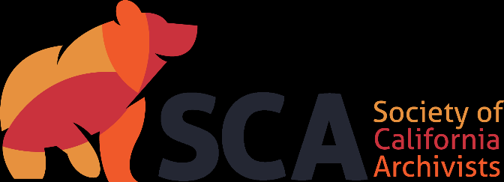

Society of California Archivists
Candidate’s Statement for 2024 Election

Candidate for: Vice President/President-elect

Years: 2024-2027 (3-year term)

Name: Sue Luftschein

Institution: USC Libraries

Professional Background (begin with current position and areas of responsibility, and briefly summarize relevant experience):
I am currently the Head of Special Collections in the USC Libraries, where I supervise 5 librarians and 2 para-professional staff, oversee public service operations and manage collection development, budgets, and facilities. I’ve been in this position since 2016; prior to that I was the Archival and Metadata Librarian at USC, responsible for all aspects of metadata creation for the department’s archival collections. I’ve also worked as a Project Archivist at the Huntington Library, and in the Institutional Records department of the J. Paul Getty Trust.

Educational Background (degrees and other applicable training):
I received my MLIS from UCLA with a concentration in archival theory and practice. I also earned a Ph.D. in art history from the CUNY Graduate Center and an MA in Art History from Temple University. My B.A. is from the University of Pennsylvania.

Professional Affiliations (list organizations, dates and extent of your involvement, e.g., SCA activities, memberships, committee work):
I have been a member of SCA since 2005. I have served variously on the Local Arrangements, Education, and Program Committees, and I am currently Newsletter Senior Co-Editor on the Publications Committee. I have chaired sessions and presented at several SCA AGMs.

I have been a member of SAA since 2005, where I currently serve on the Standards Committee. Prior to that, I served two terms on TS-DACS, including two years as co-chair. I was also on the Steering Committee for the Encoded Archival Standards Section. I’ve served as a peer reviewer for American Archivist and have organized sessions and presented at the conference on several occasions.

In what direction do you see the Society moving in the next five years? What role should the Society play on a state, regional, and national basis?
SCA has always been an incredibly important organization to me in my professional work. Not only for the opportunities to network and meet peers across the state, but also to stay abreast of changes in professional practice. SCA has always been a more affordable alternative to SAA, and that is something that I have always appreciated—I’ve attended more SCA AGMs than SAA annual meetings! Our organization’s commitment to inclusivity and equity in this way has been one of its more appealing characteristics. I am hoping to be able to explore other, and more, ways to create affordable opportunities for our membership to gather, exchange ideas, and educate ourselves. The more we learn, the greater our collective and individual opportunities for leadership. Remaining affordable, especially considering the challenges we face in the labor market, is so important to ensuring the future of our profession. I want to see SCA continue to be a leader in providing opportunities for our members, and others interested in what we do, to grow and harness our collective power to effect change and move forward.
As one of dozens of state and regional archival associations nation-wide, we have an obligation to advocate for issues that directly affect us, in California, the West, and nationally. Maintaining relationships with the California State Archives is of importance, but working with the Regional Archival Associations Consortium (RAAC) provides us opportunities to have our voices heard on a national stage. The President is our conduit and I would be committed to maintaining an open line of communication both to and from RAAC.

Please detail your efforts to integrate equity and inclusion practices into your work and any plans you may have for this as Vice President/President-elect.

As a volunteer organization, SCA has an obligation to ensure that all members have a voice. The diverse nature of our membership is an asset as it allows for a wide variety of perspectives on all topics of interest to the membership. I plan to continue and reinforce all existing opportunities for the membership to have their voices heard, and to establish multiple avenues for communication—regular online or in person get-togethers that will provide opportunities for conversation with the board members, developing a Q&A section of the quarterly board meetings that will be open to the membership, and/or asking members to submit and present agenda items for the board meetings. I’d also like to see SCA develop a leadership mentorship program to provide opportunities for new members to get a thorough understanding of what it means to be a “leader” in SCA—board member, committee chair, etc.—and to encourage members to volunteer. I remember, as a new member, being mystified by the operational aspects of the organization, and actions like these would be one way to support demystification.
In my own work, I advance equity and inclusivity through leadership initiatives as well as through collection building. For example, I led the group that developed the USC Libraries’ statement on anti-racist description, and I strive to create an environment where everyone knows their voices matter.

