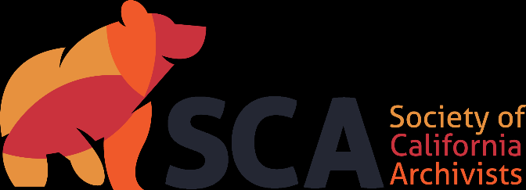

Society of California Archivists
Candidate’s Statement for 2024 Election

Candidate for: Director-at-Large

Years: 2024-2026 (2-year term)

Name: Charla DelaCuadra

Institution: UC Irvine

Professional Background (begin with current position and areas of responsibility, and briefly summarize experience): Currently I work as the Manuscripts Processor at UC Irvine Special Collections and Archives, where I am responsible for processing both digital and paper-based collections across our collecting areas, including the OC Regional Archive, Southeast Asian Archive, and more. Previously I worked for two years in the History Center of the Orange Public Library, and for almost 10 years as an archivist at the Huntington Library, Art Museum, and Botanical Gardens. There I processed and cataloged over a hundred years of visual materials as well as a variety of other collections, including the LA Times and the Institutional Archives.

Educational Background (degrees and other applicable training):
Bachelor of Music in flute performance, Chapman University
Master of Arts in Musicology with Archival Studies emphasis, Claremont Graduate University

Professional Affiliations (list organizations, dates and extent of your involvement, e.g., SCA activities, memberships, committee work): I have been an active SCA member since 2011, when I joined as a nervous and introverted grad student. SCA welcomed me with open arms, and I have since served on both the Education and Publicity and Outreach committees for a number of years, including 3 years as Committee Co-Chair for the latter as we merged and revamped it into the Communications and Outreach committee. It was a welcome challenge and one I happily took on.

[300 words or less]

This position represents the membership at large on the SCA Board. What are your immediate concerns about the Society, and what projects would you like to see accomplished during your term? I am most interested in how the SCA can best be of service, with a special interest in serving its members, and particularly inclusive with said service. I was welcomed immediately as a young archivist beginning my career, and I would love to be able to continue to keep SCA a valuable resource for its membership.

Please detail your efforts to integrate equity and inclusion practices into your work and any plans you may have for this as Director-at-Large. I have become deeply dedicated to integrating diversity, equity, and inclusion into the archival profession in the last several years. At the Huntington I helped spearhead an archives reading group for curators, archivists, and other staff to explore these issues, and I’d like to think our discussion and efforts bore no small part in expanding the reading room access at our institution from a traditionally elite researcher group to a much more expansive readership. I’d like to take these kinds of ideas and discussions to the SCA itself as well as fellow members’ institutions. Broader and more equitable archival access is a win for all of us, both archivists and end-users alike. We have a huge responsibility as record-keepers: we decide whose stories are important, who deserves to be included in the dialogue, and who will be remembered by history. It is our job as archivists to take this responsibility on with awareness and active concern for equity and inclusion.

